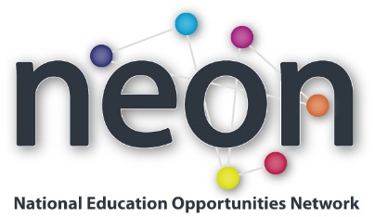
Access, Success and the Student Lifecycle: An International Perspective
Tuesday 11 November 2014
1:30pm – 4:30pm

We are moving into another new phase in the development of widening access work in England, as we start to focus with greater energy on the progression of learners from under-represented groups into, through and out of HE. NEON wants to develop its work to support the access community to meet these new challenges. This seminar will look at how we can link outreach, learning and teaching and employability work in HE to support underrepresented groups across the student lifecycle. It looks at the challenge and innovation in both England and internationally.

We are delighted to welcome a guest speaker Professor June Pym, Director of Educational Development, University of Cape Town. The seminar will help shape the future direction of the work of NEON in this area.

1.15pm  1.30pm | Registration  Welcome, Dr Graeme Atherton
1.45pm | The importance of student lifecycle - Professor Les Ebdon (invited)
2.00pm | Outreach and the student lifecycle - Steve Kendall, Associate Dean of Partnerships and Director of Widening Participation, University of Bedfordshire.
2.20pm | Supporting First Generation Students: A South African Perspective – Professor June Pym, Director of Educational Development, University of Cape Town
2:50pm | Employability and widening access – Linda Buckham, Director, Careers and Employability Centre, University of Sussex.
3.15pm | Break
3.30pm | Panel Discussion
4.15pm  4.30pm | Summary and what NEON should do next – Dr Graeme Atherton  Seminar ends

